ASSIGNMENT No : 11
TITLE : Interface Implementation
Problem Statement
Write a Java program to demonstrate the implementation of interfaces.
Name of Student: Husam Ali Abdalla Nour | PRN:25070122086
Semester: III | Year : AY 2026-27
Subject: Programming with Java

Learning Objectives
To implement interfaces for achieving abstraction and multiple inheritance of type.

Programme
interface Animal
{ void sound(); // abstract method
}
class Dog implements Animal
{ public void sound()
{
System.out.println("dog barks "); }
}
class chat implements Animal
{ public void sound()
{
System.out.println("chat crie means cat "); }
}
class matou extends chat
{ public void sound()
{
System.out.println("matou is cat in other language ");
}
}
public class Interface
{ public static void main(String[] args) {
Animal a = new Dog(); Animal b = new chat();
chat m = new matou(); a.sound();
b.sound();
m.sound();
}
}

Output
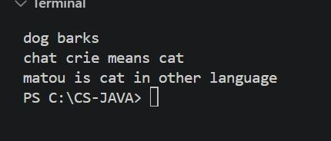

Conclusion
In conclusion, an interface provides a simple way for users to interact with a software system. It makes the application easier to use by allowing users to give inputs and view outputs. A welldesigned interface improves user experience, efficiency, and accessibility.

